Okelo,
Upon reviewing the Home page of your online portfolio, I have several suggestions for edits that would improve a viewer's comprehension of it, as well as give them more to take away.
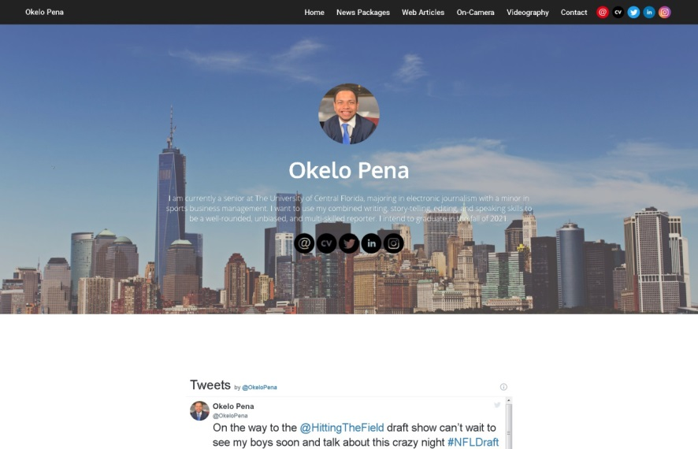
First, let's talk about what dominates your page. You've got a huge picture of the Manhattan skyline and a giant Twitter widget that, together, seem to shrink your name, introduction and profile picture. Additionally, what you've written is genuinely difficult to read on such a backdrop. Here are some suggestions for you, denoted by the C.R.A.P. principles of web design:
C stands for contrast, and we can make your text much easier to read in one of a few ways. Right now, we have white text in front of a dynamic, colorful banner image. For a bit of trivia, did you know that the first generation of top text/bottom text memes fixed this problem with outlines? How else would they have been so easy to read, no matter what the background image is?
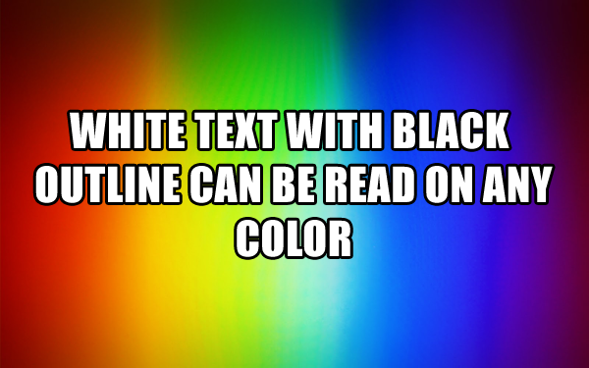
Going off of that, the most basic change I can suggest here is to use a bigger font, and to employ some method of setting it off from the background. I'm not saying to use the Impact font, as it's become the new Comic Sans, but consider adding a translucent block of color between the text and background if possible, or use a text that's wide enough for us to see it in 4K.
R stands for repetition, and A stands for alignment. I'd like to interpret both principles here in a way that bolsters your portfolio's continuity by establishing a structural theme. Addressing your Twitter widget, in addition to making it smaller, I say you should align it toward the right of the page, while reserving the space on the left for the rest of your content. In doing so, you're giving yourself the opportunity to add the smaller Twitter widget to other pages without compromising their content, as most adhere to NSM formatting requirements first and foremost. In general, you should also be including more pictures of yourself in action here and there; your best chance to do this is on your Contact page, which is especially barren.
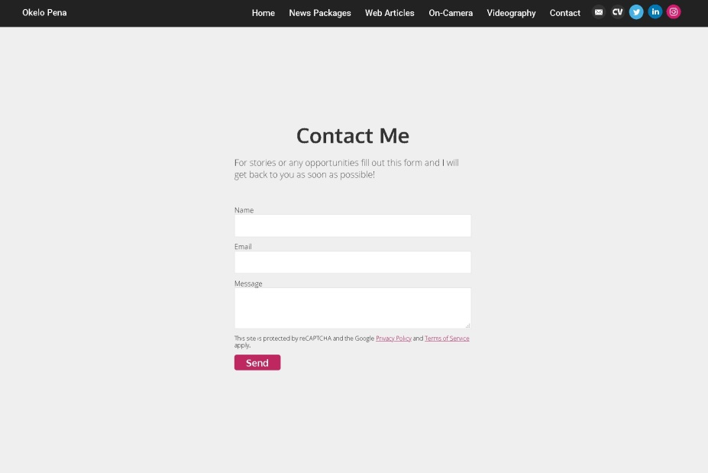
P, stand for proximity, and your portfolio needs to build a bit of muscle if our new structural changes are going to look full, per se. You may want to include a gallery, but you don't need any more widgets otherwise. Instead, I suggest that you write a bit more about yourself. If you're going to show us a picture of the Big Apple, for example, why not tie yourself to it? Each page could be enhanced by a description of what's in them placed at the top.
Lastly, you'll want to be mindful of potential redundancies. It's not setting off an alarm in my head, but the double-features of the words 'Okelo Pena' and your social media links on your Home page could throw someone off, especially someone who's looking to hire an editor. In cases when you must decide which to delete, go with the less-noticeable one.
Please reach out to me if you have any questions, or if you need technical help as you hopefully go off of my advice. I look forward to seeing this website improve, and I'll keep an eye out for your next message.

Brandon

